**Assignment III (MA226)**

**Name: Sourav Bikash**

**Roll No.:11012338**

**Submission Date: 25/01/2013 Time:23:59 hrs.**

**Aim of the Problem:**

The problem involves the use of a linear congruence generator. The basic aim lies in the fact that although it generates a large number of values, the values are not randomly distributed. And there exists a definition to these distributions.

**Mathematical Analysis/Theory:**

The problem uses the following linear congruence generator:





It generates a sequence of xi and a dependent sequence ui.

For the second part of the problem we make use of the extended Fibonacci generator. This is given by:



This requires buffering of 17 values.

**Part I:**

A sequence of xi was generated using the linear congruence generator. Using this a sequence of Ui was obtained. The frequencies of the obtained Ui was plotted using a barplot.

**C++ implementation:**

#include<iostream>

#include<climits>

#define N 100000

using namespace std;

int axmodm(int m, int a, int x)

{

int q = m/a;

int r = m%a;

int k = x/q;

x = a * (x - k * q) - k * r;

if(x < 0)

x += m;

return x;

}

void generate(int m, int a)

{

//daclaring variables

int x0 = 1, count, j;

double *u;

int frequency[20][3];// three frequncies 1000,10000,100000

u = new double[N];// store frequencies in this array

int sum[3] = {0, 0, 0};

//initialising frequency array

for(count = 0; count < 20; count++)

{

frequency[count][0] = frequency[count][1] = frequency[count][2] = 0;

}

//calculating frequencies

for(count = 0; count < N; count++)

{

u[count] = (x0*1.0)/m;

if(count < 1000)

{

frequency[(int)(u[count]/0.05)][0]++;

frequency[(int)(u[count]/0.05)][1]++;

frequency[(int)(u[count]/0.05)][2]++;

}

else if(count < 10000)

{

frequency[(int)(u[count]/0.05)][1]++;

frequency[(int)(u[count]/0.05)][2]++;

}

else if(count < N)

{

frequency[(int)(u[count]/0.05)][2]++;

}

x0 = axmodm(m, a, x0);

}

//display frequency

for(count = 0; count < 20; count++)

{

cout<<frequency[count][0]<<'\t'<<frequency[count][1]<<'\t'<<frequency[count][2]<<endl;

sum[0]+=frequency[count][0];

sum[1]+=frequency[count][1];

sum[2]+=frequency[count][2];

}

cout<<sum[0]<<'\t'<<sum[1]<<'\t'<<sum[2]<<endl;

}

void coordinates(int m, int a)

{

//declaring variables

int x0 = 1, count, j;

double *u;

u = new double[N];

//display coordinates

for(count = 0; count < N; count++)

{

u[count] = (x0*1.0)/m;

if(count == 0)

{

cout<<u[count]<<endl;

}

else

{

cout<<'\t'<<u[count]<<endl<<u[count];

}

x0 = axmodm(m, a, x0);

}

}

void generate17(int m, int a)

{

//declaring variables

int x0 = 1, count;

//displaying sequence

for(count = 0; count < 17; count++)

{

cout<<x0<<endl;

x0 = axmodm(m, a, x0);

}

}

int main(int argc, char **argv)

{

if(argc == 1)

{

generate(INT_MAX, 16807);//INT_MAX is the maximum int value of the compiler(32-bit in this case)

generate(2147483399, 40692);

generate(2147483563, 40014);

}

else if(argv[1][0] == '1')

{

coordinates(INT_MAX, 16807);

}

else if(argv[1][0] == '2')

{

generate17(INT_MAX, 16807);

}

return 0;

}

**Using the output bar plot were generated:**

**Using a=16807,b=0, m=231-1**

1. For N=1000

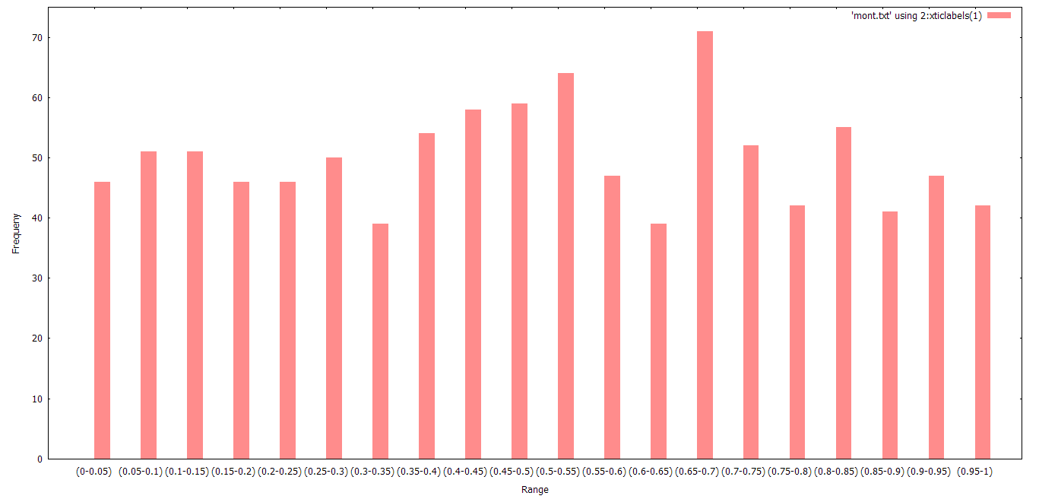

1. For N=10000

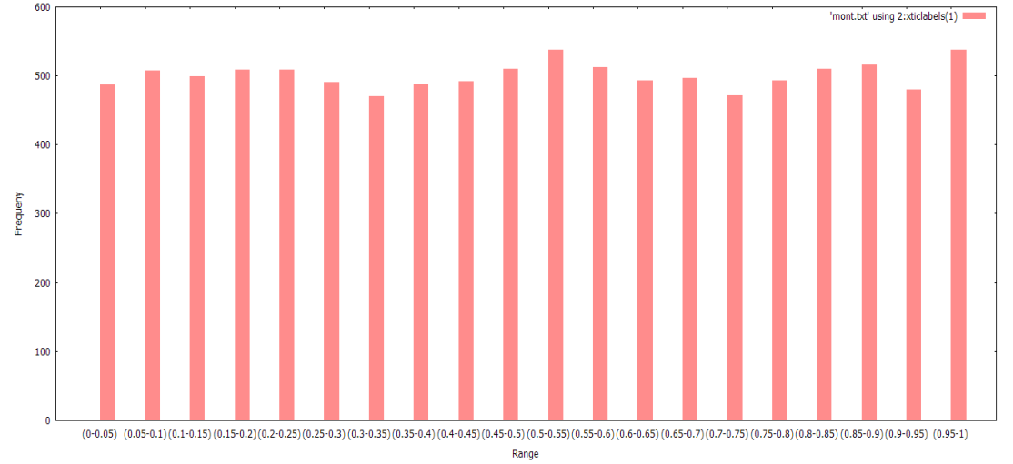

1. For N=100000

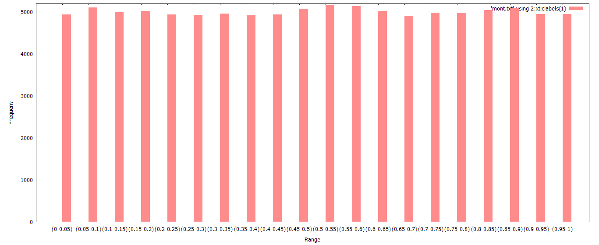

Using a=40692,b=0,m=2147483399.

1. For N=1000

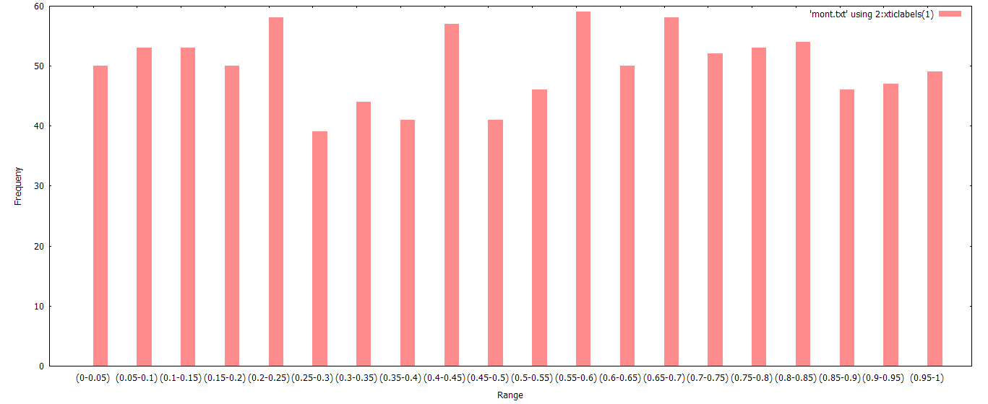

1. For N=10000

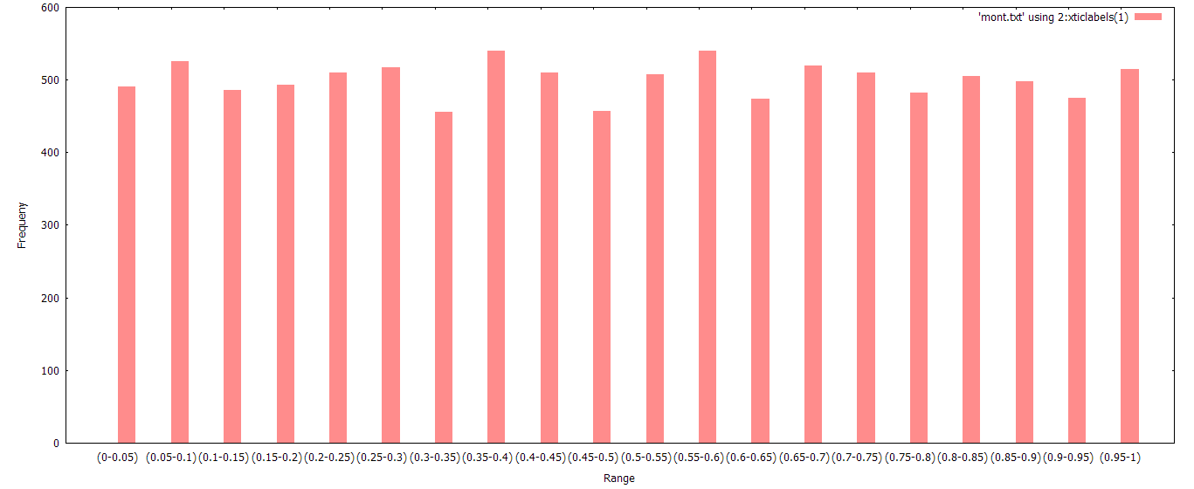

1. For N=100000

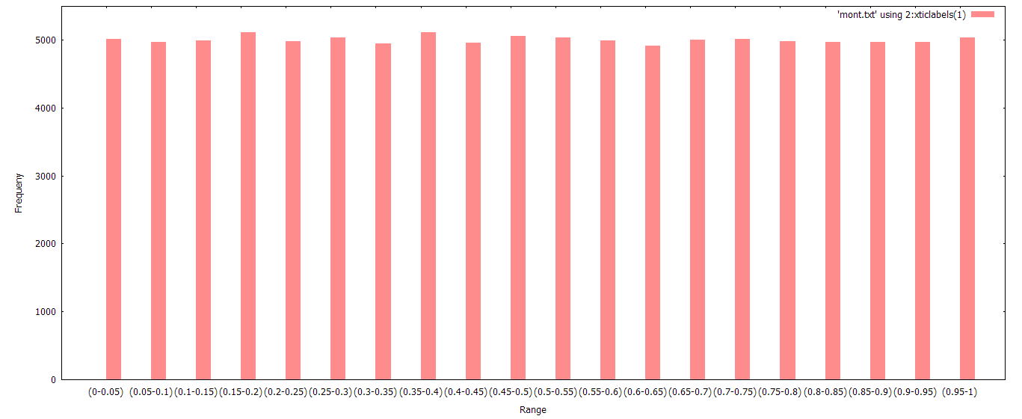

Using a=40014,b=0,m=2147483563

1. For N=1000

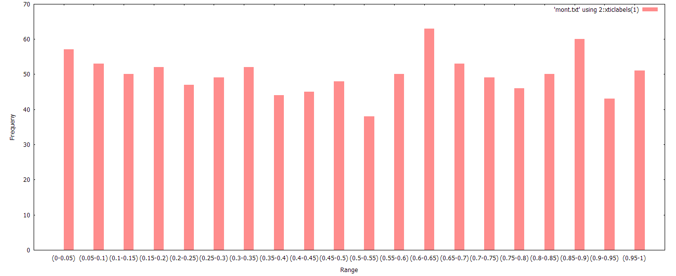

1. For N=10000

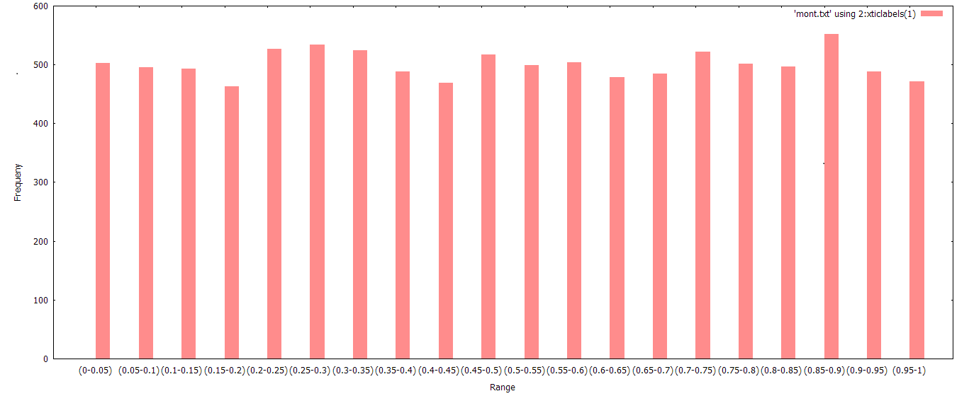

1. For N=100000

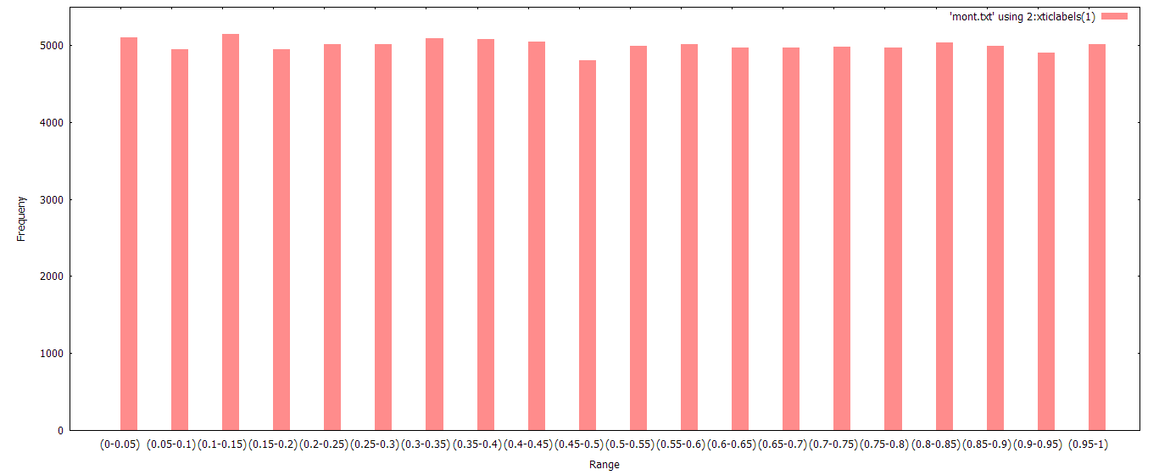

The plot of Ui vs Ui-1:

For N=1000

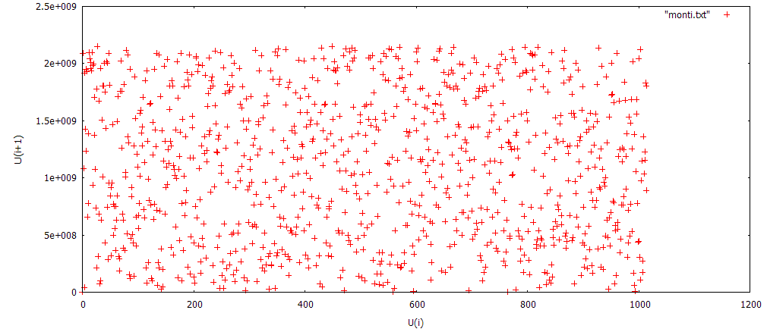

For N=10000

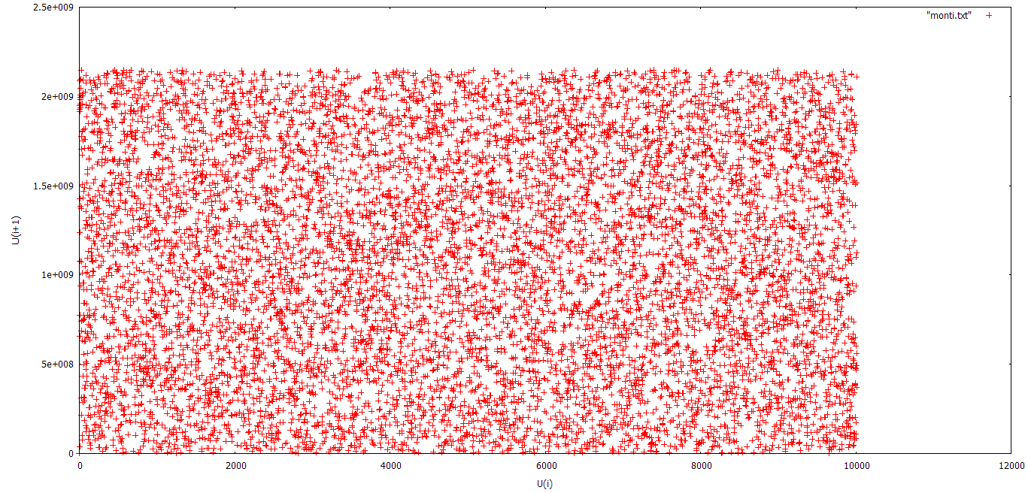

For N=100000

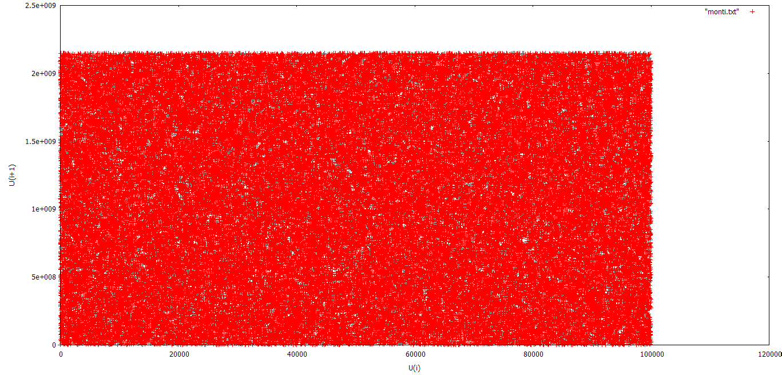

**Observations:**

From the bar plot we can see that the greater the value of N, the frequency tend to stabilise near a value (N/20).

**Magnification of the plot:**

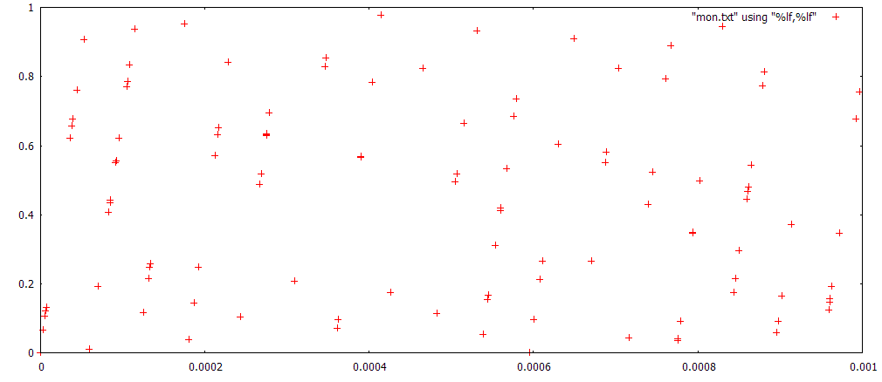

**Part II:**

This part focuses on the use of extended Fibonacci generators to generate nos.

First 17 buffer values was generated using the linear congruence generator of the previous problem.

C++ implementation:

#include<iostream>

#include<climits>

#include<cmath>

#define N 1000

using namespace std;

unsigned int *u;

unsigned int eFib(int index)

{

unsigned int ui, temp;

ui = (u[index-5] + u[index-17]) % (INT_MAX+1);

return ui;

}

int main(int argc, char **argv)

{

//declaring variables

int count, max;

double mean = 0;

double variance = 0;

double temp;

int f[50];

double p[50];

u = new unsigned int[N];

//taking the starting 17 values

for(count = 0; count < 17; count++)

{

cin>>u[count];

}

//u[0] = 2147483647;

count = 17;

//generating sequence

while(count < N)

{

u[count] = eFib(count);

count++;

}

if(argv[1][0] == 'c')

{

switch(argv[1][1])

{

case '1':

max = 1000;

break;

case '2':

max = 10000;

break;

case '3':

max = 100000;

break;

}

for(count = 1; count < max; count++)

{

cout<<u[count-1]<<'\t'<<u[count]<<endl;

}

}

else if(argv[1][0] == 'd')

{

//calculate mean

mean = u[0];

for(count = 1; count < 1000; count++)

{

mean = mean + (u[count] - mean*1.0)/(count + 1);

}

//calculate variance

for(count = 0; count < 1000; count++)

{

variance = pow(u[count]*1.0 - mean, 2);

}

variance = variance/1000.0;

cout<<(unsigned int)mean<<endl;

cout<<variance<<endl;

//calculate probability distribution

for(count = 0; count < 50; count++)

{

f[count] = 0;

}

for(count = 0; count < 1000; count++)

{

temp = (u[count]*1.0)/pow(2.0, 15);

temp = temp/pow(2.0, 16);

f[(int)(temp/0.02)]++;

}

double pd[50];

pd[0] = 0;

for(count = 0; count < 50; count++)

{

p[count] = f[count]/1000.0;

if(count == 0)

{

pd[count] = p[count];

}

else

{

pd[count] = pd[count-1] + p[count];

}

cout<<pd[count]<<endl;

}

}

else if(argv[1][0] == 'e')

{

//calculating autocorrelation values

double temp1 = 0, temp2 = 0;

double autoc[5];

for(count = 0; count < 1000; count++)

{

temp2 += ((double)u[count] - (double)mean)*((double)u[count] - (double)mean);

}

cout<<temp2<<endl;

for(max = 0; max < 5; max++)

{

temp1 = 0;

for(count = max+1; count < 1000; count++)

{

temp1 += 1.0*((double)u[count] - (double)mean)*((double)u[count-1] - (double)mean);

}

autoc[max] = temp1/temp2;

cout<<temp1<<endl;

}

for(count = 0; count < 5; count++)

cout<<autoc[count]<<endl;

}

return 0;

}

Using the data obtained:

The following plots were obtained;

1. For N=1000

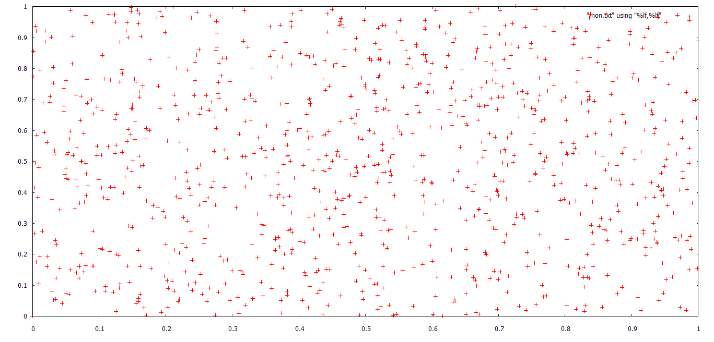

1. For N=10000

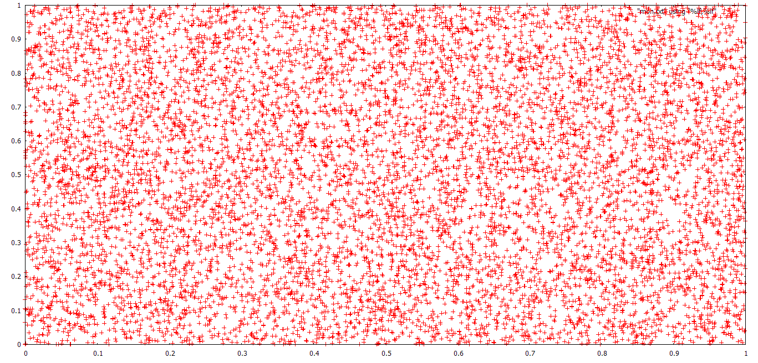

1. For N=100000

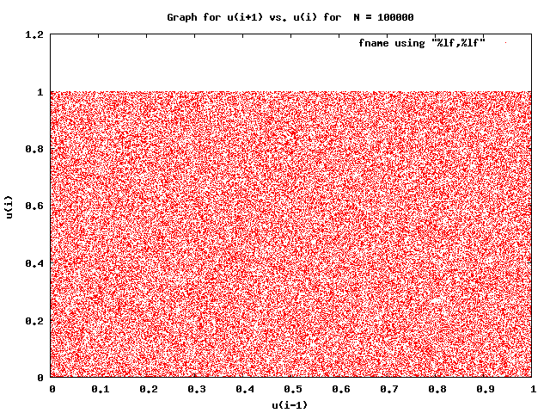

The cumulative probability distribution plot so obtained: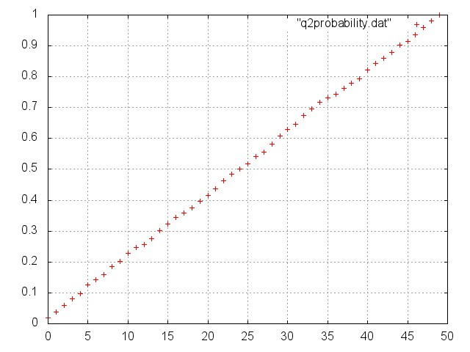

The cumulative probability distribution curve so obtained:

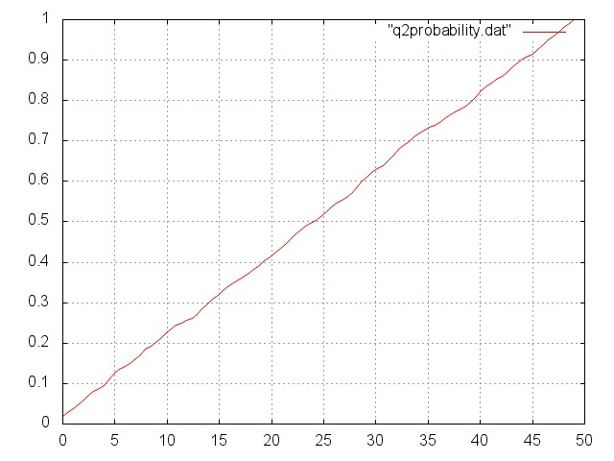

**Observations:**

The autocorrelation lags calculated from the above program tends very close to zero. However if the numbers are independent it should simply be zero. The Fibonacci generator passes all statistical tests and is certainly a better generator than the LCG.